Maximal Rectangles
Problem Statement: Given a m x n binary matrix filled with 0's and 1's, find the largest rectangle containing only 1's and return its area.
Example 1:
Input: matrix = [[1, 0, 1, 0, 0], [1, 0, 1, 1, 1], [1, 1, 1, 1, 1], [1, 0, 0, 1, 0]]
Output: 6
Explanation: The largest rectangle of only 1's has area 6, formed by the 2×3 block of 1's in rows 1 and 2, columns 2 to 4.
Algorithm
- Convert the binary matrix into a matrix of histogram heights using the prefix sum technique
- For each cell in the histogram matrix, calculate the height of consecutive 1's ending at that cell
- If a cell contains a 0, reset the height to 0
- For each row in the histogram matrix, treat it as a histogram and compute the largest rectangle area
- Use a stack-based approach to find the largest rectangle in the histogram for each row
- Track the maximum rectangle area found across all rows
- Return the maximum rectangle area as the result
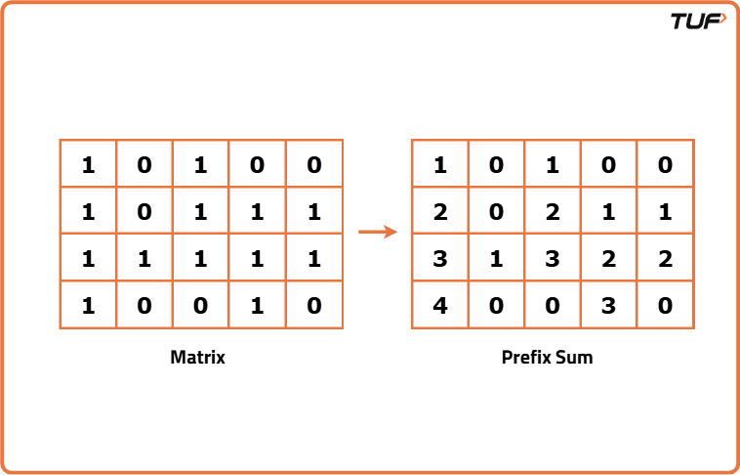

class Solution {
private int largestRectangleArea(int[] heights) {
int ans = 0;
Deque<Integer> stack = new ArrayDeque<>();
for (int i = 0; i <= heights.length; ++i) {
while (!stack.isEmpty() && (i == heights.length || heights[stack.peek()] > heights[i])) {
final int h = heights[stack.pop()];
final int w = stack.isEmpty() ? i : i - stack.peek() - 1;
ans = Math.max(ans, h * w);
}
stack.push(i);
}
return ans;
}
public int maximalRectangle(char[][] matrix) {
if (matrix.length == 0) return 0;
int ans = 0;
int[] hist = new int[matrix[0].length];
for (char[] row : matrix) {
for (int i = 0; i < row.length; ++i)
hist[i] = row[i] == '0' ? 0 : hist[i] + 1;
ans = Math.max(ans, largestRectangleArea(hist));
}
return ans;
}
}
Time Complexity: O(N*M), since filling the prefix sum matrix takes O(N*M) time, and every row (of length M) is treated as a histogram for which the largest histogram is found in linear(O(2*M)). Thus, time taking overall is O(N*M).
Space Complexity: O(N*M), since the prefix sum array takes up O(N*M) space, and finding the largest rectangle in each histogram (of length M) takes O(M) space due to stack.

